ITP 120VT Module 5 Laboratory

In the Assignment tab of our Portal page download the file itp120mod5_1718.jar and itp120mod5deitel.jar. The second one has the examples from the textbook. The first one is the one we will be looking at in this module. There are a number of packages in this file. YOU WILL ONLY BE TURNING BACK IN A PACKAGE NAMED dwolffmod5 (except with your name) with the programs shown at the bottom of this document.

In the lab module, write your comments in the text box (see the syllabus for information). Attach your jar file back in the Assignment and submit it back through the portal.

- Let’s first look at using arrays for collecting items together. Arrays have the advantage of being very fast and very useful if you know how many items your collection will hold.
- Let’s first look at arrays of primitive data types. We will be looking at samples in the mod5wolff01arraysPrimitive package of our jar file.
- Why do we need collections? Look at Ex1NoArrays and Ex2NeedsArrays. Read the comments. Arrays store sets of data for later use.
- Ex3SumArray shows you how to use an initializer for setting values in the array while you declare it. A nice short hand way to do this if you know the data ahead of time.
- Look at Ex4. and Ex5. You need to know how large an array is at creation time, but you can ask the user at runtime and create the correct size, if that is an option. If not, you will need to create an array bigger than you ever need (see Ex6.). In this case, you need to keep a running counter of how many of the entries are valid. If you fill the array and need more room, you could make the array bigger and copy the current data into the new array (see Ex7.). Note carefully in this example how the method call and the method definition handle arrays. You do not give a size in the method definition but do include the [ ]. In the method call you just use the array name.
- Ex8. shows an example of the enhanced for loop discussed in the text.
- Your book discusses the use of the Arrays class and some methods for searching and sorting arrays from this class. You should also be familiar with searching and sorting via the actual algorithms. The last programs in this package demonstrate this.
- You often want to have arrays of reference data types. Check out the BandBooster and Dog examples in the mod5wolff02arraysClasses package.
- Look at the blueprint for a ExCD. Nothing new here. We have a four private instance variables, the constructors, toString(), and getters and setters.
- Now we want to have another blueprint class that represents a collection of CDs. Look at the ExCDCollection class. The instance variables include a collection of CD objects, a total cost, and an integer that keeps track of how many CDs are present. This last instance variable is required if you do not know how many CDs are present. Note that the constructor creates an array large enough for 100 CDs. Study the code for the addCD() method and the increaseSize() methods. We not only have to keep track of how many actual CDs that are present, we also need to deal with making the array bigger if you collect over 100 CDs. Run the driver program (ExTunes) and see how the execution proceeds.
- Look at the programs in the package named mod5wolff03SalesArray. This example revisits the sales that we had in the previous module. But in this case, we can use arrays to improve the program and store the inventory, customers, and sales.
- To do: RAINFALLDRIVER CLASS

RAINFALL CLASS
Write a RainfallDriver class that has the following methods:
- main which creates an array of rainfall values for a year. Use the following to do so:
double[] rain = {.5,.3,.7,1.2,.1,.8,2.1,.5,3.3,2.8,.9,1.2};

- a method that calculates and prints the total rainfall for the year named total()
- a method that calculates and prints the average monthly rainfall named average()
- a method that determines and print the maximum rain in any one month named max()
- a method that determines and prints the minimum rain in any one month named min()
Each of the last four methods will need to define the array as a parameter that is passed in on the method call. So the methods will have a single parameter which is a double[].

After you create the array in main, call each of the four methods so that they can print their information. Check out Ex9PrimitiveArrayWithMethods for an example on how to start.
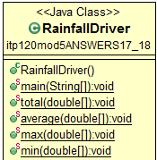

Sample output:
The total rainfall for the year is: 14.4
The average monthly rainfall is: 1.2
The maximum monthly rainfall is: 3.3
The minimum monthly rainfall is: 0.1

- To do:
Write a program named RandomDiceDriver. Your program should have a for loop that rolls a single die 100 times. Create an integer array named rolls of size seven. We will store the number of rolls for that value in each location (note: there will be nothing stored in the zeroth location since you cannot roll a zero).
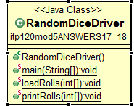

- To do:
  - You work at a coffee shop where you take drink orders. Create a class named Drinks with the following fields. Make certain to include all methods required in our class blueprint.
private String drinkType;
private char size; (//NOTE valid values are S, M, or L for small, medium, large)
private double costEach;
private int numOrdered;

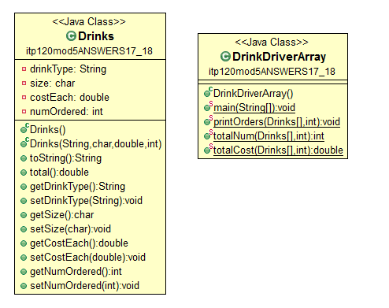

  - We are going to create an array of Drink instances in a driver named DrinkDriverArray and fill in data from the keyboard. We do not know how many there are ahead of time. We have examples of how to handle arrays of unknown size. Check out DogArrayUnknownSize.java. NOTE: it MUST be an array – not an ArrayList. Let’s assume that we will not have over 20 different drink orders so make your program to handle any number of them up to 20 (you do not need to write an increaseSize() method).
  - The main loop should just be reading in the data by asking the user for values for the four fields, creating the instances and placing them in the array. You can end the loop any way that you like.
  - Create methods shown in the UML diagram above.
(NOTE: since these methods are related to multiple orders, they must go in the driver class – not the blueprint. The only thing that can go into the blueprint is anything that has to do with ONE Drink order.
  - After your loop in main(), call the three methods in d. above to print out the data and summaries.
HINT: since we do not know the size of the array, you will need a counter and each of the three methods above will have parameters of the Ticket array and that counter. Check out the DogArrayListUnknownSize. For similar calculations, also check out the BandBoosters (except that one is a full array, so you will need to pass in the counter that indicates how many pieces of data are actually valid).

Sample output at the bottom

- There are many problems with using arrays including:
- You must know how large the array is when you created it. It is not resizable. So you often write a method that is used to increase the size when needed. We saw such methods in the examples above. Note that copying large arrays is very inefficient.
- There is a length property that tells you how large the created array is, but not how many pieces of actual valid data are in it. For instance, in the Dog/ DogArray program above, let’s say you did not know how many dogs there were. You typically then make the array bigger than you would ever need. Then you must have a variable that keeps track how many pieces of data are really entered as we did with the CDs.
- Arrays are very hard to insert and delete data from, especially for the center elements. For instance, assume that the array help alphabetized words and you wanted to add one in the middle or delete one from the center. Think about the problems this would cause.
- Arrays contain no methods. Methods are what make Java classes so powerful!
- An alternative way to store a set of objects is in an ArrayList. This is part of the Java Collections and is found in the java.util package. ArrayLists have a rich set of methods as we saw briefly at the end of the chapter in your text. Watch the Collaborate movie on ArrayLists.
- Remember to be able to utilize methods, we need to know a) the name b) the parameter(s) c) the return type. All of this is obtainable if we just know how to read APIs.
- Look at the samples in the mod5wolff04ArrayLists package. Look at Ex1Grades. ArrayLists are collections if reference data types – not primitives! If I want to maintain an ArrayList of whole numbers, I need to use the Integer wrapper class (we discussed wrapper classes previously). But with boxing and unboxing, Java allows implicit casting from int to Integer, double to Double, etc. With this, we can define the ArrayList to be the wrapper class but add primitive values to it. Note that this ArrayList is defined as containing Integers but line 16 adds the primitive int input from the keyboard to it.
- Look at Ex2ALDogs. The example we studied earlier used an array of Dog instances. This one takes that code and converts it over to an ArrayList. note how that was done.
- Also look at the Ex3BookDriverAL that uses the Book blueprint. Keep studying these blueprints so you can write them in your sleep!
- To do: We will now write a driver using ArrayLists for our Drink class from #14 above. Make a copy of the DrinkDriverArray and name it DrinkDriverArrayList. Convert this program from an array collection to an ArrayList. You do not need to make any changes in the Drink program (that one blueprint will work for both drivers or any type of collection). We want it to use an ArrayList instead of an array. If you have problems, study the code for Birds, BirdsArray, and the converted BirdsArrayList.
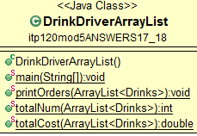
- Look at the code for Ex5BaseballPlayers as you look at the APIs. Study the code and match each method call for the name, parameter(s) and return type.
- To do: Now add code to Ex5BaseballPlayers to complete the comments in the code.
- Check out the mod5wolff05SalesArrayList version of our Sales program using an ArrayList in place of the array.
- Let’s look at another association that utilizes ArrayLists. Now we will rent some wrecked cars. Here is the UML diagram for our application (found in the mod5wolff06rentawreck package.

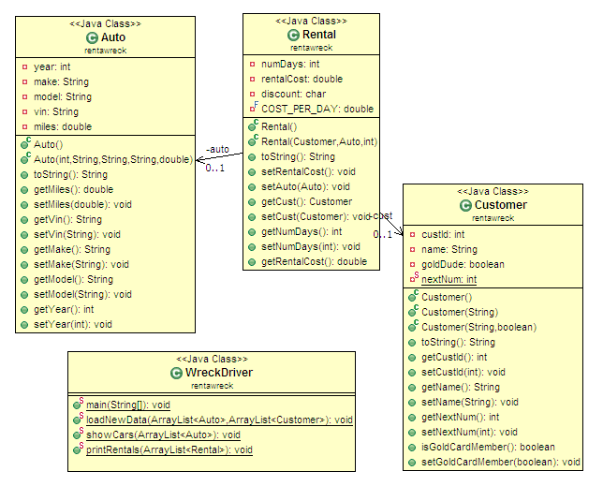

- Some of our business rules for the rentals:
- All rentals are $15.00/day (I wish!)
- We give a 15% discount if they rent for over 6 days.
- We give Gold Card members an extra 10% a day.
- We need to hard code some data into the program. I have a table of data for you to use.
- Note the associations in this application (the Rental contains a Customer and an Auto).
- To do: Finish the Rentals class (see the comments with “TO DO”) and the WreckDriver class. Note that I have written a stub method for main() which you need to complete to get sample output similar to mine below. You can make changes to the other two classes if you like, but do not need to. Sample output is below.
- Now we need to document our hard work!! Look at my Customer class in the SalesArrayList application. I have added JavaDocs for the class, each field and each method. You do the same for the Sales class. In production, this is required as the standard documentation for every class.
- Go to http://agile.csc.ncsu.edu/SEMaterials/tutorials/javadoc/ and http://www.mcs.csueastbay.edu/~billard/se/cs3340/ex7/javadoctutorial.html for information on how to write Javadocs. Look at JavaDocEclipse.doc (in this module assignment in Blackboard) for information on how to add them and generate them in Eclipse.
- Then generate the JavaDocs. Find the Sales.html file. Copy and paste it you’re your package that you are submitting for mod 5 (you can just use CTRL-C followed by CTRL-P to copy and paste). Please do not zip them! I want one jar file as we normally have.

Your final jar file that you submit to me needs to have 10 programs total in a single package named dwolffmod5 (except with your name):
- Step 12: RainfallDriver
- Step 13: RandomDiceDriver
- Step 14: Drink and DrinkDriverArray
- Step 21: DrinkDriverArrayList
- Step 23: Ex5BaseballPlayers
- Step 28: Rentals, Customer, WreckDriver, Auto
- Step 31: Sales.html

Sample Output from RainfallDriver
The total rainfall for the year is: 14.4
The average monthly rainfall is: 1.2
The maximum monthly rainfall is: 3.3
The minimum monthly rainfall is: 0.1

Sample output from RandomDiceDriver
100 random rolls of the dice gave the following distribution:
1: 12
2: 17
3: 14
4: 28
5: 12
6: 17

Sample output from Drinks and DrinksDriverArray (same output for DrinksDriverArrayList)

Enter the type of drink
unsweetened ice tea
What size? (S, M, or L)
L
Enter the cost of each drink:
2.30
Enter the number of these drinks purchased:
4
Enter another drink order? (yes or no)
yes
Enter the type of drink
black coffee
What size? (S, M, or L)
M
Enter the cost of each drink:
3.10
Enter the number of these drinks purchased:
2
Enter another drink order? (yes or no)
no
The orders are:
You ordered 4 large unsweetened ice tea at $2.30 for each drink. The total cost was $9.20
You ordered 2 medium black coffee at $3.10 for each drink. The total cost was $6.20
The total number of tickets purchased is 6.
The cost of all the drinks purchased for all orders is $15.40.

Sample output from the wreck:

Customers:
1 Brett Farve (custID: 100)
2 Bruce Springsteen (custID: 101)
3 Mickey Mouse (custID: 102)
4 Peyton Manning (custID: 103)
5 Donald Duck (custID: 104)

Which customer? 2
This customer is a gold card member so we will treat him well!

The following cars are available to rent...
1. a 2009 Ford Mustang with a VIN# of ABC123 and a mileage of 1256.54
2. a 2010 Chevy Camero with a VIN# of QWI459 and a mileage of 33.98
3. a 1970 Pink Cadillac with a VIN# of 950AKH and a mileage of 212874.51
4. a 2007 Lotus Elise MkII with a VIN# of 1A2D3F and a mileage of 12859.9

Which auto? 3

How many days do you wish to have this beautiful vehicle? 10
Bruce Springsteen (custID: 101) rented a 1970 Pink Cadillac with a VIN# of 950AKH and a mileage of 212874.51 for 10 days.
The cost was $112.50
This person was both a gold card member and rented over six days and received a a 25% discount

More rentals (true/false)? true

Customers:
1 Brett Farve (custID: 100)
2 Bruce Springsteen (custID: 101)
3 Mickey Mouse (custID: 102)
4 Peyton Manning (custID: 103)
5 Donald Duck (custID: 104)

Which customer? 4
This customer is a gold card member so we will treat him well!

The following cars are available to rent...
1. a 2009 Ford Mustang with a VIN# of ABC123 and a mileage of 1256.54
2. a 2010 Chevy Camero with a VIN# of QWI459 and a mileage of 33.98
3. a 1970 Pink Cadillac with a VIN# of 950AKH and a mileage of 212874.51
4. a 2007 Lotus Elise MkII with a VIN# of 1A2D3F and a mileage of 12859.9

Which auto? 4

How many days do you wish to have this beautiful vehicle? 1
Peyton Manning (custID: 103) rented a 2007 Lotus Elise MkII with a VIN# of 1A2D3F and a mileage of 12859.9 for 1 days.
The cost was $13.50
This person was a gold card member and received a 10% discount

More rentals (true/false)? true

Customers:
1 Brett Farve (custID: 100)
2 Bruce Springsteen (custID: 101)
3 Mickey Mouse (custID: 102)
4 Peyton Manning (custID: 103)
5 Donald Duck (custID: 104)

Which customer? 1
This customer is not a gold card member

The following cars are available to rent...
1. a 2009 Ford Mustang with a VIN# of ABC123 and a mileage of 1256.54
2. a 2010 Chevy Camero with a VIN# of QWI459 and a mileage of 33.98
3. a 1970 Pink Cadillac with a VIN# of 950AKH and a mileage of 212874.51
4. a 2007 Lotus Elise MkII with a VIN# of 1A2D3F and a mileage of 12859.9

Which auto? 1

How many days do you wish to have this beautiful vehicle? 15
Brett Farve (custID: 100) rented a 2009 Ford Mustang with a VIN# of ABC123 and a mileage of 1256.54 for 15 days.
The cost was $191.25
This person rented over six days and received a 15% discount

More rentals (true/false)? false

Rental summary:
Bruce Springsteen (custID: 101) rented a 1970 Pink Cadillac with a VIN# of 950AKH and a mileage of 212874.51 for 10 days.
The cost was $112.50
This person was both a gold card member and rented over six days and received a a 25% discount
Peyton Manning (custID: 103) rented a 2007 Lotus Elise MkII with a VIN# of 1A2D3F and a mileage of 12859.9 for 1 days.
The cost was $13.50
This person was a gold card member and received a a 10% discount
Brett Farve (custID: 100) rented a 2009 Ford Mustang with a VIN# of ABC123 and a mileage of 1256.54 for 15 days.
The cost was $191.25
This person rented over six days and received a 15% discount

